**Electronic Voting System using Facial Recognition and Biometrics**

*Submitted in partial fulfillment of the requirements for the degree of*

**Bachelor of Technology**

In

**Computer Science and Engineering**

by:

**LAKSHAY NANDA**

**16BCE0805**

Under the guidance of:

**Prof. Ushus Elizebeth Zachariah**

**SCOPE**

**VIT, Vellore**



May, 2020

**DECLARATION**

I hereby declare that the thesis entitled “***Electronic Voting System using Facial Recognition and Biometrics***" submitted by me, for the award of the degree of ***Bachelor of Technology in Computer Science*** *and Engineering* to VIT is a record of bonafide work carried out by me under the supervision of ***Prof. Ushus Elizebeth Zachariah***.

I further declare that the work reported during this thesis has not been submitted and cannot be submitted, either partially or fully, for the award of any other degree or diploma during this institute or the other institute or university.

Place : Vellore

Date : 28th May 2020

**Signature of the Candidate**

Lakshay Nanda

16BCE0805



SCOPE

**CERTIFICATE**

This is to certify that the thesis entitled “**Electronic Voting System using Facial Recognition and Biometrics**” submitted by **Lakshay Nanda, 16BCE0805, SCOPE**, for the award of the degree of **Bachelor of Technology in Computer Science and Engineering** to VIT, Vellore is a record of bonafide work carried out by him under the supervision during 13.12.2019 to 5.06.2020, as per the VIT code of academic and research ethics.

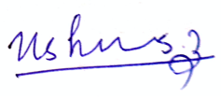The contents of this report have not been submitted and will not be submitted either in part or in full, for the award of any other degree or diploma in this institute or any other institute or university. The thesis fulfills the requirements and regulations of the University and in my opinion meets the necessary standards for submission

Place : Vellore **Signature of the Guide**

Date : 28th May 2020

**Internal Examiner External Examiner**

**Head of the Department**

**SCOPE**

**INTERNSHIP LETTER**

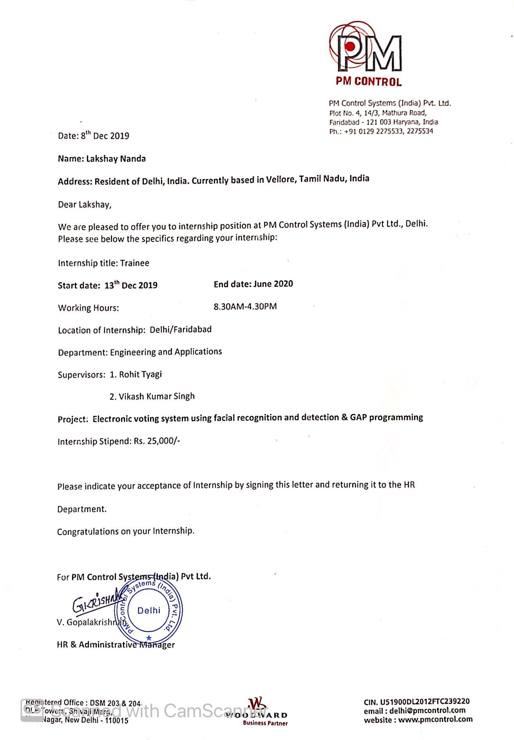

**PROJECT COMPLETION LETTER**

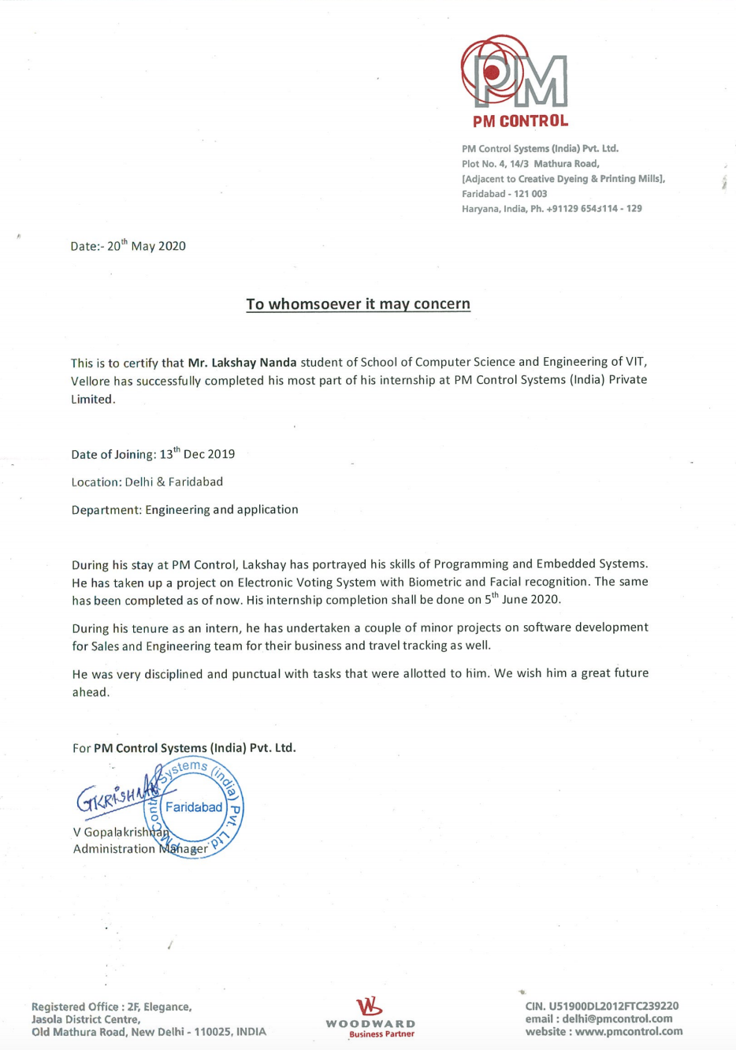

**PATENT APPLICATION:**

202011013061

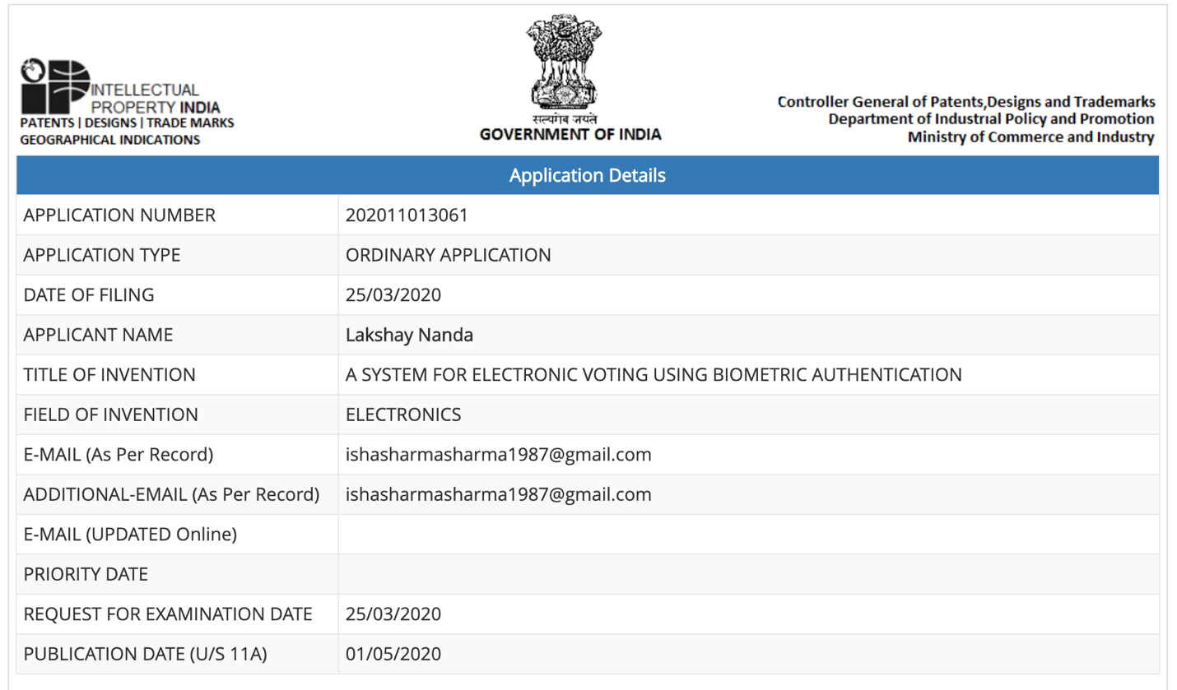

**ACKNOWLEDGEMENT**

I would want to offer my most profound thanks towards each and every individual who helped me all through this undertaking. I might want to thank my guide, **Prof. Ushus Elizebeth Zachariah** for her steady direction and backing. Her recommendation and inspiration to improve helped me get through this venture. I might likewise want to thank my ranking director **Mr. Rohit Tyagi**, who helped me traverse all the deterrents that came my direction, and furthermore for furnishing me with this open door in any case. I am thankful to my prompt guide, **Mr. Vikas Kumar**, who has consistently bolstered me helping me improve quality. A major thank you to the whole **PM Control Systems Team**, who helped out me, while dealing with this undertaking.

I would likewise want to thank the **SCOPE** Vellore, who have continually bolstered me. I express gratitude toward Vellore Institute of Technology whose scholastic educational plan includes such an industry rich encounter. I thank all the staff and resources of **VIT University** who make the foundation out of the Institute.

Last however not the least, I would want to thank my folks for being with me through my best and most noticeably awful and for making me who I am today.

**Lakshay Nanda**

**i.**

**EXECUTIVE SUMMARY**

The essential target of this undertaking is gotten from the ongoing episodes that occurred during the time spent decisions in India led by Election Commission of India (ECI). The essential case of the charges raised were during the **General Elections**, which expressed that there had been counterfeit democratic the country over. Individuals were paid off to let another person vote for their benefit which is completely against the constitution of India and a fundamental rule of reasonable and clean political decision standards forced by the ECI. The subsequent charge came during February 2020, **Delhi Elections**, which saw another flood with contentions that expressed that the EVMs were exchanged and all the clergymen went to the vote checking focus to guarantee nothing of this sort is occurring. This struck me exceptionally hard and I thought of building up a propelled instrument that can guarantee free and safe races without causing obliteration of the fundamental standards of a majority rules system. To conquer these disadvantages, I built up an Electronic Voting Machine with biometric security and facial acknowledgment to guarantee just the individual himself/herself can give vote, keeping away from intermediary casting a ballot and furthermore, timestamps are recorded each time somebody gives their vote. This would guarantee that no sham democratic happens and the EVMs can't be exchanged.

**ii.**

**CONTENTS PAGE NO.**

**Acknowledgement** i

**Executive Summary** ii

**Table of Contents** iii

**List of Figures** iv

**List of Tables** v

**Abbreviations** vi

**1 INTRODUCTION** 1

1.1 Objective 1

1.2 Motivation 2

1.3 Background 3

**2 LITERATURE REVIEW** 5

**3 PROJECT DESCRIPTION AND GOALS** 7

**4 TECHNICAL SPECIFICATION** 8

**5 DESIGN APPROACH AND DETAILS** 13

5.1 Design Approach 13

5.2 Standards and Codes 19

5.3 Alternatives, constraints and trade-offs 24

**6 SCHEDULE, TASKS AND MILESTONES** 25

**7 PROJECT DEMONSTRATION** 26

**8 RESULT AND DISCUSSION** 30

**9 REVIEW SUMMARY** 32

**REFERENCES** 33

**APPENDIX A** 34

**LIST OF FIGURES**

**Fig No. Figure Title Page No.** 1 Framework proposed in this report 8

2 Liquid Crystal Display 16x2 9

3 Keyboard 9

4 Serial Communicator 10

5 Alarm 10

6 Module to scan fingerprint 11

7 Adapter to hold SD 11

8 Camera being used 12

9 Block diagram to demonstrate working 13

10 Design of the system 14

11 Demonstrating working using flow diagram(1) 16

12 Demonstrating working using flow diagram(2) 17

13 dataset for facial recognition 20

14 training on the dataset 20

15 detecting hardware while software is running (1) 21

16 detecting hardware while software is running (2) 21

17 Buzzer and Code to set cursor 22

18 Check which key is pressed 23

19 Delete a user 23

20 Arduino Vote Method 24

21 tasks by months and weeks 25

22 Complete set up 26

23 Only hardware setup 26

24 Facial Recognition working 27

25 Method for facial recognition 27

26 Classifier being used Is HAAR 28

27 Algorithm for HAAR 29

28 face does not match but fingerprint matches 30

29 Face is not found but fingerprint matches 31

30 User has already voted 31

**LIST OF TABLES**

**Table no. Caption Page No.**

1 fingerprint module and Arduino connections 15

2Arduino Connection for LCD 15

**v.**

**ABBREVIATIONS**

**ID:** Identification

**ECI:** Election Commission of India

**R305:** Finger Print Sensor

**GoI:** Government of India

**UART:** Universal Asynchronous Receiver/Transmitter

**EVM:** Electronic Voting Machine

**POLL:** Polling

**DRE:** Direct Recording Electronic

**TBC:** Test Bus Controller

**AES:** Advanced Encryption Standard

**LCD:** Liquid Crystal Display

**PTC:** Parametric Technology Corporation

**vi.**

**CHAPTER 1**

**INTRODUCTION**

* 1. **Objective**

To develop an EVM which utilises facial recognition and fingerprint as the security feature which permits a person to cast their vote was a tough task. India is a democratic nation with majority of its population uneducated. They come under the influence of the politicians very easily and sometimes there is a news that bogus voting took place and proxy voters were caught. To avoid all this I thought of introducing these two features in EVM which will eliminate these things plus there would be side benefits of having reduced the cost of elections, additional man power and anywhere voting. All that requires only one thing, that you should be registered in AADHAR database. There are several things that need we need to do. First register fingerprint. There is a LED Screen that passes instructions.

**1.**

**1.2 Motivation**

The primary motivation was the allegations raised during the **General** **Elections** (Lok Sabha), which stated that there had been bogus voting across the nation. People were paid off to let someone else vote on their behalf which is absolutely against the constitution of India and a basic principle of fair and clean election norms imposed by the ECI. The second motivation for this process came during February 2020, **Delhi Elections**, which saw another surge with arguments that stated that the EVMs were switched and all the ministers came to the vote counting centre to ensure nothing of this sort is happening. In order to mitigate any such activity, I thought of working on this project, as it can be very helpful for the ECI to conduct elections. The incentive was to develop a system that can help people vote at their convenience to any place they want as they would be registered in the AADHAR database, which is the primary and the only source for the EVM to fetch user data to match with the one given on polling site. This would help reduce time of voting, keeps a track of the data as and when it will be taking a vote. No redundancy and no bogus voting.

**2.**

**1.3 Background**

To develop an EVM which utilises facial recognition and fingerprint as the security feature which permits a person to cast their vote was a tough task. India is a democratic nation with majority of its population uneducated. They come under the influence of the politicians very easily and sometimes there is a news that bogus voting took place and proxy voters were caught. To avoid all this I thought of introducing these two features in EVM which will eliminate these things plus there would be side benefits of having reduced the cost of elections, additional man power and anywhere voting. All that requires only one thing, that you should be registered in AADHAR database. There are several things that need we need to do. First register fingerprint. There is a LED Screen that passes instructions. Finger is placed twice to confirm and match the image scan. And an ID is assigned to each user which is a secret ID just like SSN. During the process of facial recognition, we need to register ourselves first. That ID needs to be provided to sync up the finger print with the face photograph. 21 images are taken. They are trained. And Finally a person is eligible to give vote. To develop an EVM which utilises facial recognition and fingerprint as the security feature which permits a person to cast their vote was a tough task. India is a democratic nation with majority of its population uneducated. They come under the influence of the politicians very easily and sometimes there is a news that bogus voting took place and proxy voters were caught. To avoid all this I thought of introducing these two features in EVM which will eliminate these things plus there would be side benefits of having reduced the cost of elections, additional man power and anywhere voting. All that requires only one thing, that you should be registered in AADHAR database. There are several things that need we need to do. First register fingerprint. There is a LED Screen that passes instructions. Finger is placed twice to confirm and match the image scan. And an ID is assigned to each user which is a secret ID just like SSN. During the

**3.**

process of facial recognition, we need to register ourselves first. That ID needs to be provided to sync up the finger print with the face photograph. 21 images are taken. They are trained. And Finally a person is eligible to give vote. The objective is to develop an EVM which utilises facial recognition and fingerprint as the security feature which permits a person to cast their vote. India is a democratic nation with majority of its population uneducated. They come under the influence of the politicians very easily and sometimes there is a news that bogus voting took place and proxy voters were caught. To avoid all this I thought of introducing these two features in EVM which will eliminate these things plus there would be side benefits of having reduced the cost of elections, additional man power and anywhere voting. All that requires only one thing, that you should be registered in AADHAR database.

**4.**

**CHAPTER 2**

**LITERATURE REVIEW**

M. Byrne, K. Greene, and S. Everett (2007) found the following:

They have focussed specifically on the voting system being utilised in the US by various companies. They have evaluated card punches, switching machines and paper voting systems. They evaluated that only difference is that mistake rate is high in manual methods whereas the latest approach is risk free. [1]

Sussane Caarls (2010) found the following:

They have specifically talked about ICT being used as a voting technique. The votes that are taken are transported to a specific spot for counting however, they have also highlighted that this kind of features dampens the chain of custody and increases the risk of vote manufacturing and switching.[2]

Santin, R. Costa and C. Maziero (2008) found that:

They have utilised a great method of helping secure the votes extracted from the machine by developing a system that continuously encrypts the vote count by using AES. Hence, they idealise the concept I have utilised in my project.[3]

Kumar (2012) found that:

His paper consisted of comparison between various types of voting machines and the advantages each machine hold over the other. It also presented various drawbacks of the machine as it did consider the requirements of the various impaired population of this country. They also quoted that we need to understand the society as a whole and develop a machine that highlights the shortcomings of the existing system and move on to design a machine that can be easily put to use and increase the votes during a phase of voting.[4]

**5.**

Jain and D. Maltoni (2003) found that:

They have made sure to highlight the important aspects of facial recognition and biometric as a whole without leaving a single factual as to why we should not ignore this kind of security. They have highlighted the features that can be utilised with in these broad categories and helped me understand how I should Implement my project without having to utilise an already existing idea.[5]

M. Khan (2009) found that:

He has talked about having to develop a fingerprint based voting machine with extra security layer so as to get rid of mal practices such as booth capturing and proxy voting with extra reinforcement. And hard shell security, not only stops these practices but also reports them immediately as they occur. [10]

M. Min and Y. Thein (2009) found that:

EVM is rising and it is having a lot of evolved set ups across the world. They have used fingerprint security to be introduced as a security feature which prevents bogus voting unlike traditional ballot voting.[9]

S. Kumar and M. Singh (2012) found that:

They are using a unique mark as a feature that can be utilised in order to reduce the number of fake voting practises that are running across the world. [7]

R. Haenni, E. Dubuis, and U. Ultes-Nitsche found that:

They have considered voting scenario in Switzerland. They took into consideration E-Voting system which is very common in their country. They evolved the system to be called anywhere voting machine. A person registered can give their vote by simply introducing a web framework to help people give vote at their convenience from their homes.[8]

**6.**

**CHAPTER 3**

**PROJECT DESCRIPTION AND GOALS**

To develop an EVM which utilises facial recognition and fingerprint as the security feature which permits a person to cast their vote was a tough task. India is a democratic nation with majority of its population uneducated. They come under the influence of the politicians very easily and sometimes there is a news that bogus voting took place and proxy voters were caught. To avoid all this I thought of introducing these two features in EVM which will eliminate these things plus there would be side benefits of having reduced the cost of elections, additional man power and anywhere voting. All that requires only one thing, that you should be registered in AADHAR database. There are several things that need we need to do. First register fingerprint. There is a LED Screen that passes instructions. Finger is placed twice to confirm and match the image scan. And an ID is assigned to each user which is a secret ID just like SSN. During the process of facial recognition, we need to register ourselves first. That ID needs to be provided to sync up the finger print with the face photograph. 21 images are taken. They are trained. And Finally a person is eligible to give vote.

The goals of this project are as mentioned below:

• **No partiality**: Nobody can get familiar with the democratic results.

• **Eligibility**: Everyone is AADHAR database can vote.

• **Individuality:** giving vote on various occasions isn’t possible.

• **Private:** Nobody can get to the information about any individual voter.

**• Accurate:** All the right votes must be considered accurately.

• **Efficient**: vote tally must be performed inside a base measure of time.

**7.**

**CHAPTER 4**

**TECHNICAL SPECIFICATION**



Fig [1]. Framework proposed in this project

The objective is to develop an EVM which utilises facial recognition and fingerprint as the security feature which permits a person to cast their vote. India is a democratic nation with majority of its population uneducated. They come under the influence of the politicians very easily and sometimes there is a news that bogus voting took place and proxy voters were caught. To avoid all this I thought of introducing these two features in EVM which will eliminate these things plus there would be side benefits of having reduced the cost of elections, additional man power and anywhere voting. All that requires only one thing, that you should be registered in AADHAR database.

**8.**

**Liquid Crystal Display 16x2:**

Helps the user move forward with the process

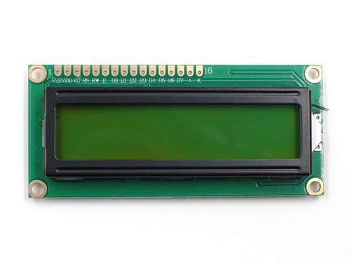

Fig [2]. Liquid Crystal Display 16x2

**Keyboard:**

Several commands need to be passed for which we are using this component

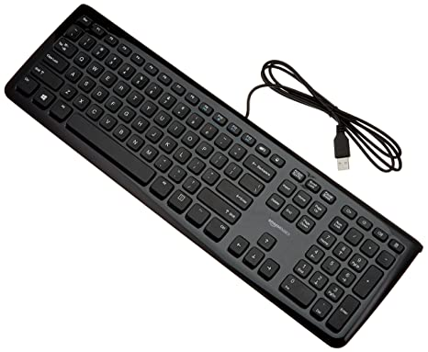

Fig [3]. Keyboard

**9.**

**RS232:**

It helps us in passing or mediating control between software and hardware part of project.

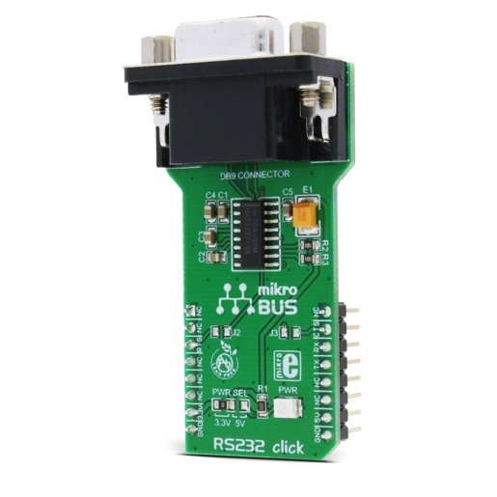

Fig [4]. Serial Communicator

**Buzzer:**

Buzzer is used to help notify that the vote was taken.

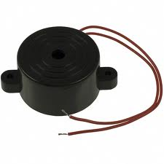

Fig [5]. Alarm

**Fingerprint module:**

Fingerprint module, R305, is utilised to capture fingerprint.

**10.**

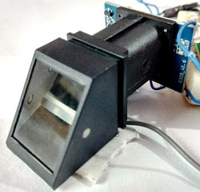

Fig [6]. Module to scan fingerprint

**Micro SD card adapter:**

Stores the resultant of the outcome of the election.

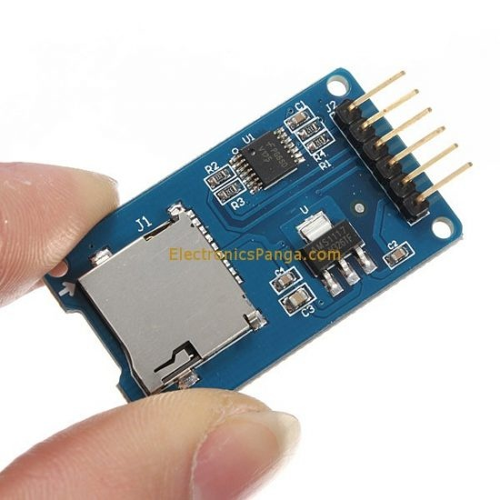

Fig [7]. Adapter to hold SD

**11.**

**Camera:**

Helps in capturing and storing images and also face detection and recognition.

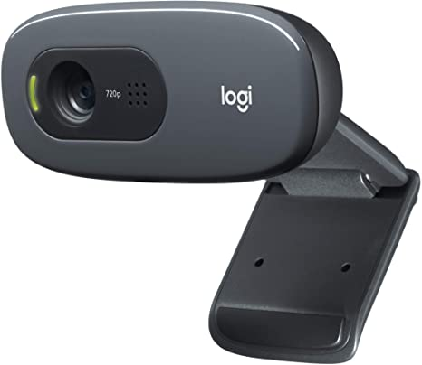

Fig [8]. Camera being used

**12.**

**CHAPTER 5**

**DESIGN APPROACH AND DETAILS**

**5.1 Design Approach**

The approach was to make the process simpler as we know that people across the nation are going to use this and hence it would be difficult for people to understand the process of registering and giving vote. As most of the population in India is illiterate, we need to make something that can be easily understood by anyone from any part of the country.

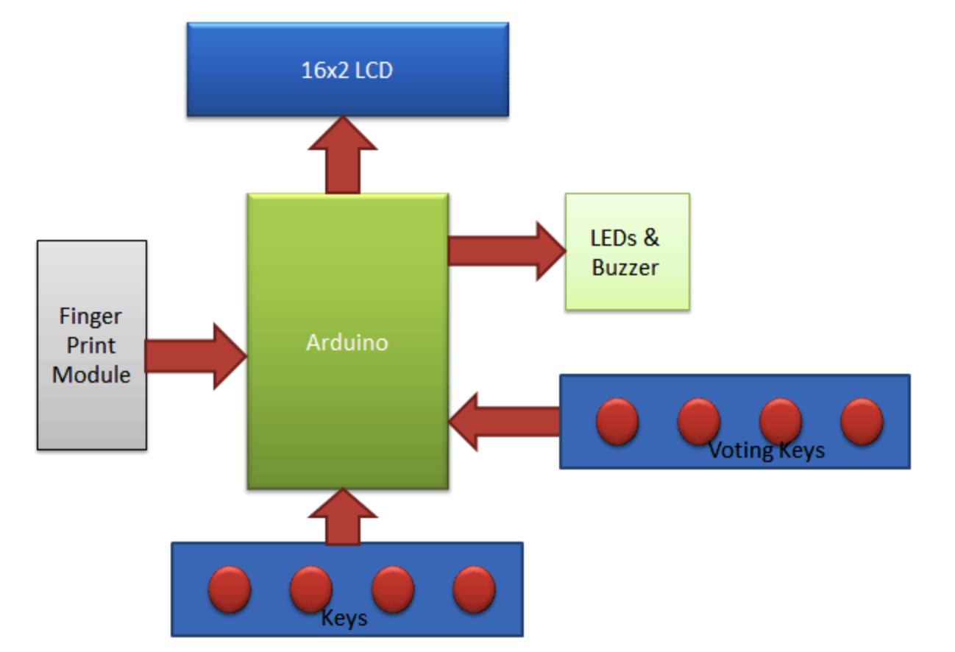

Fig [9]. Block diagram to demonstrate working

User must ensure that they have not already registered as they overwrite the original user who registered with that number. First finger is registered then we proceed towards capturing face. For which we use HAAR classifier. Once that is also done we move towards the process of voting.

**13.**

The project starts by taking dataset of 21 images by calling the datasetgenerator.py file. Once that is done we proceed towards training those 21 images with HAAR. After that we proceed towards linking software and hardware part. Haar Cascade is a ML object discovery calculation which is utilized to distinguish protests in a picture or video. Haar Cascade is neural network library that is used to discover object occurrence and calculates how dissimilar a picture or video is. It is an AI relied technology where a strategy is prepared from a massive amounts pictures that it takes as dataset.

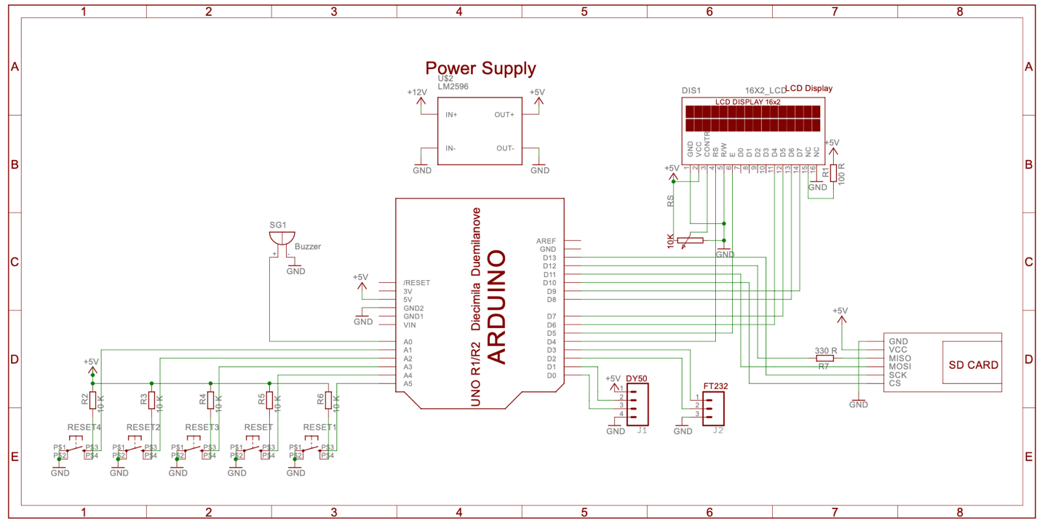

Fig [10]. Design of the System

For deleting a user the person needs to press the last button in the voting keys with the reset button on the arduino.

**14.**

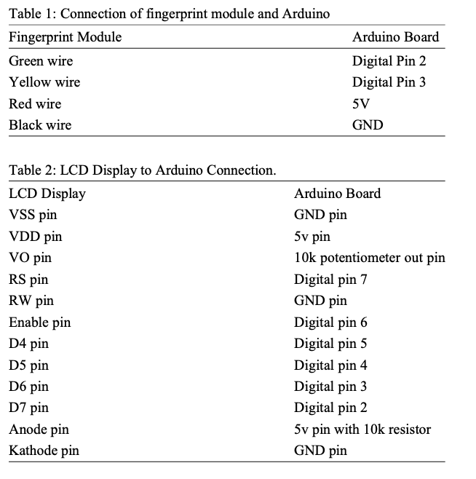

The above tables specify the pin numbers of each component being utilised and the pin it is attached to. It will help a newbie to understand the structure and working of the project.

**15.**

**Proposed System Model:**

The procedure is rather simple.

**Step 1:** Input of your national identification.

**Step 2:** Check if it is valid

**Step 3:** IF valid- Scan Fingerprint

ELSE – Tell its invalid

**Step 4:** Rescan fingerprint- checks if it is correctly stored

**Step 5:** Generate ID for the fingerprint

**Step 6:** Check if already registered

**Step 7:** IF not already registered move towards face capturing

**Step 8:** Takes 20-25 images

**Step 9:** Asks for the ID of the fingerprint to match face with the fingerprint

**Step 10:** Store all information in the database.

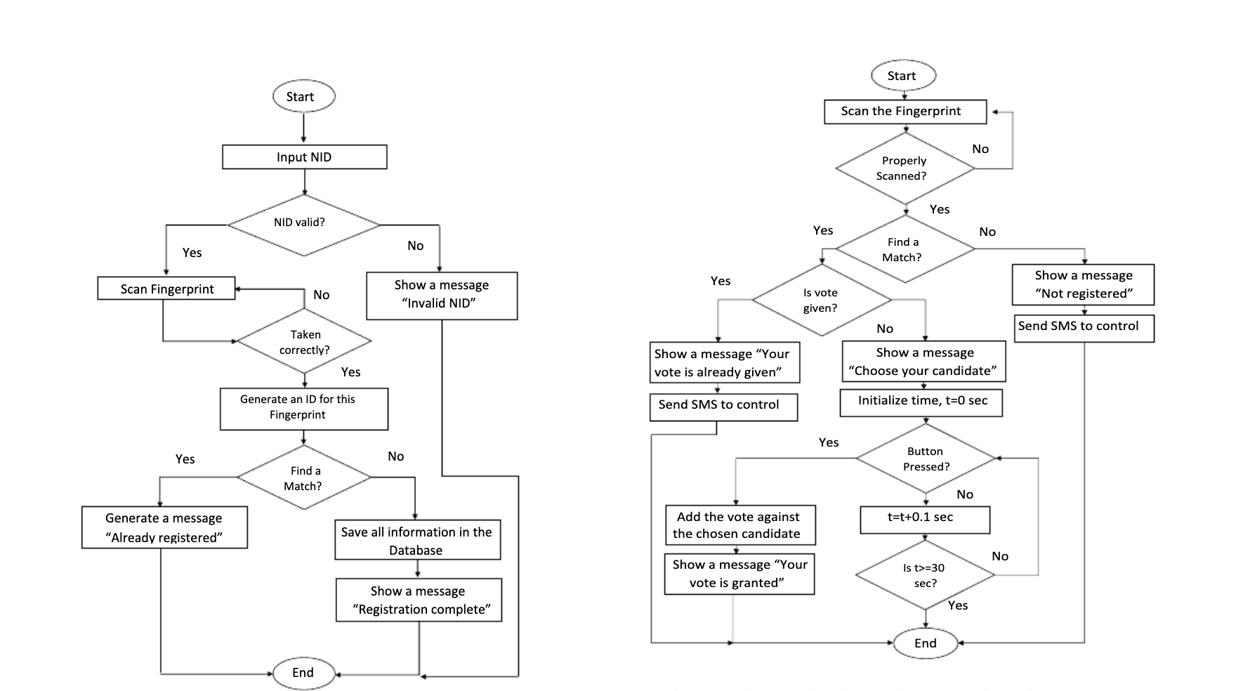

Fig [11]. Demonstrating working using flow diagram(1)

**16.**

**Working Future Scope:**



Fig [12]. Demonstrating working using flow diagram (2)

I intend to add a SMS feature to this model to ensure the vote is recorded. It will send a message immediately with in 30s to ensure the user that his vote was taken into account immediately after vote was casted.

**17.**

**Advantages:**

* Only people with authentic fingerprint and face match can cast vote.
* No human assistance required
* Very cheap
* Does not take a lot of time, only 20 s per voter
* Power dissipation is very less and hence would help reduce the cost eventually

**Reason for shifting to biometric security:**

1.Election activities are restricted in some areas because people think there vote doesn’t matter. Therefore, there is a need to reduce such activities and make people go out to give vote.

2.The procedure that already exists is very trivial and involves a lot of manpower. We can reduce that and along with it the cost of conducting a democratic election process.

**Existing System:**

The current scenario in India is very different than the rest of the world. Our votes do not carry enough value as people think that whatever happens, there will be people who will turn the vote count in their favour. The voting takes place in public areas like schools or MCD offices. They utilise a ballot based EVM which requires a lot of supervision by people who will go and check your voter id, your name in the list and then place a mark on your finger, only then would you be permitted to vote. I say all that is a waste of resources as people can simply use their body features which are unique to them to cast vote. They have unique fingerprint and facial features which can be exploited to help them give vote. Eliminating the need of so many layers in the existing model of voting in the largest democracy in the world.

**18.**

**5.2 Codes and Standards**

The project starts by taking dataset of 21 images by calling the datasetgenerator.py file.Once that is done we proceed towards training those 21 images with HAAR. After that we proceed towards linking software and hardware part. Haar Cascade is a ML object discovery calculation which is utilized to distinguish protests in a picture or video. Haar Cascade is neural network library that is used to discover object occurrence and calculates how dissimilar a picture or video is. It is an AI relied technology where a strategy is prepared from a massive amounts pictures that it takes as dataset.

The algorithm has four stages:

* Feature Shortlisting
* Covering up for incomplete images
* Adaboost is employed
* Classifiers that are cascading are used thereafter

It reports dissimilar body features in an image but they can spot almost any feature. Primarily, Haar classification need a lot of pictures. After that highlights need to be separated.

**19.**

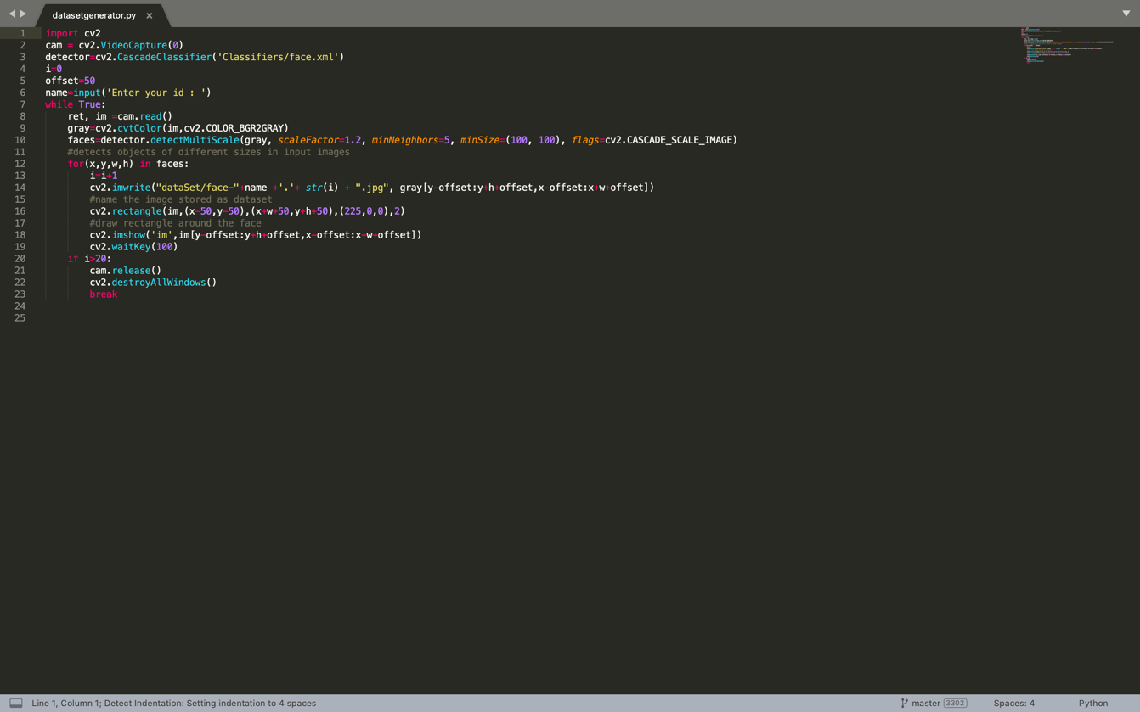

Fig [13]. dataset for facial recognition

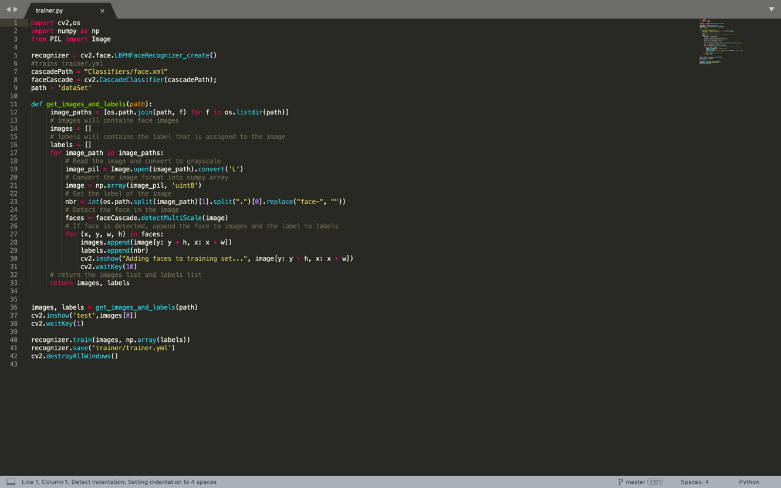

Fig [14]. Training on the dataset

**20.**

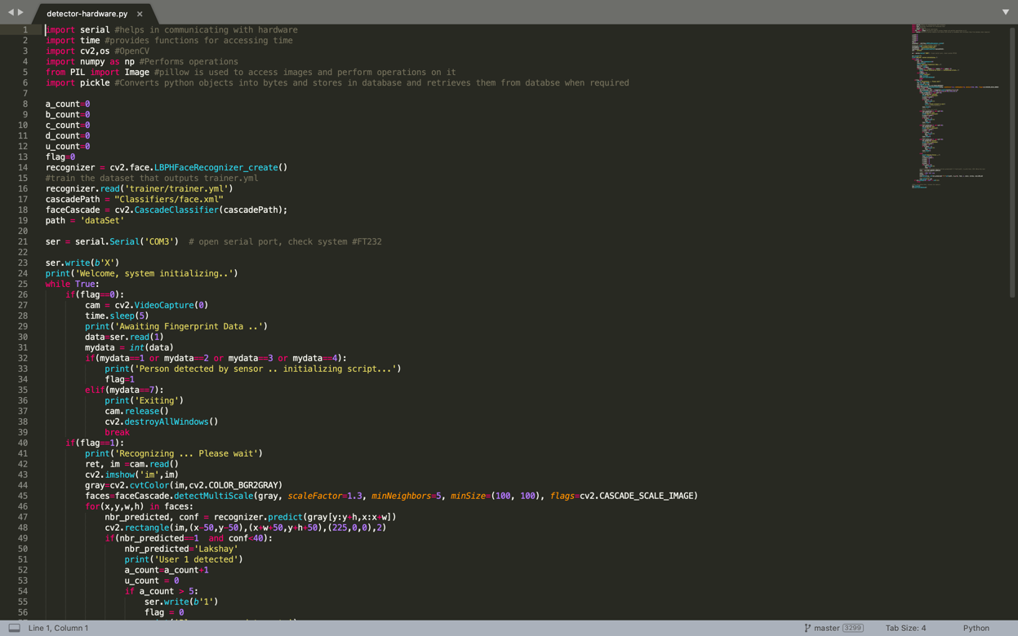

Fig [15]. detecting hardware while software is running (1)

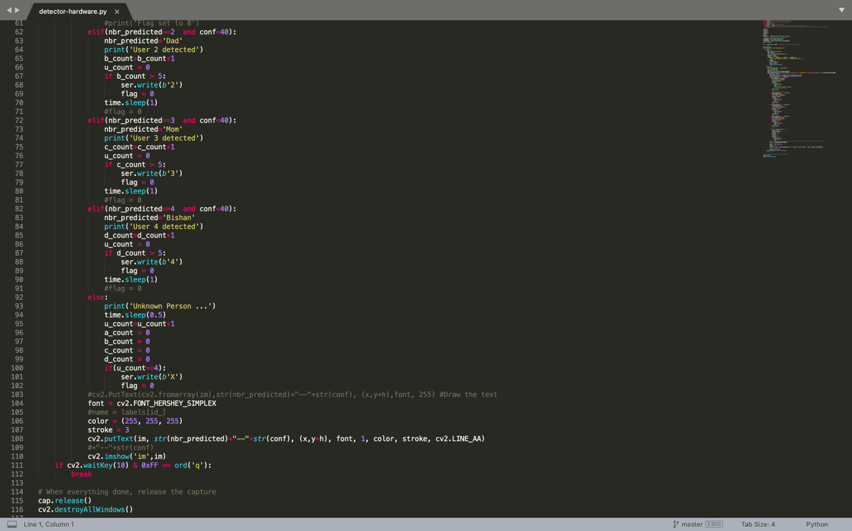

Fig [16]. detecting hardware while software is running (2)

**21.**

This Arduino program utilises Adafruit Library for capturing fingerprint. Setup is used for basic printing and initialisation. After that, in loop, we start to capture fingerprint. If it matches then good else it moves on and keeps detecting until a match is found.

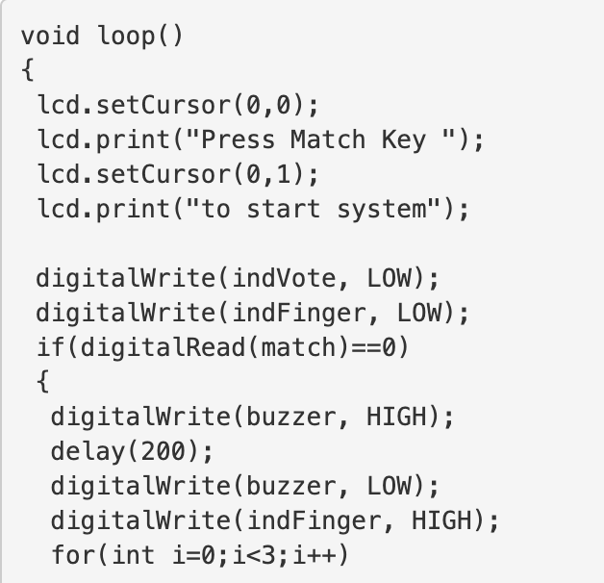

Fig [17]. Buzzer and Code to set cursor

Void function mentioned below is used to what button was pressed. If the number key is pressed the enrolment function is called else the function to delete a user has been called:

**22.**

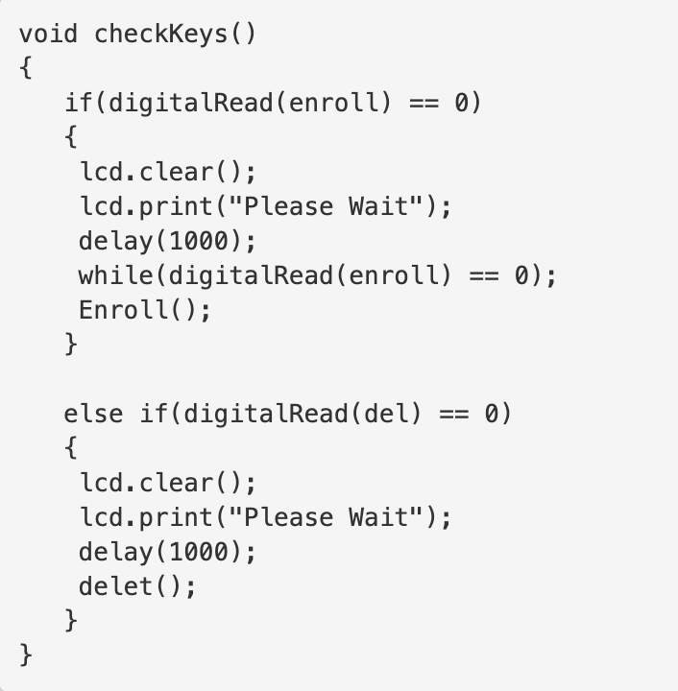

Fig [18]. Check which key was pressed

Now moving towards deleting the fingerprints in the database. We need to specify the ID that we need to delete. That will call delet() function. This will delete any records linked to the particular ID specified.

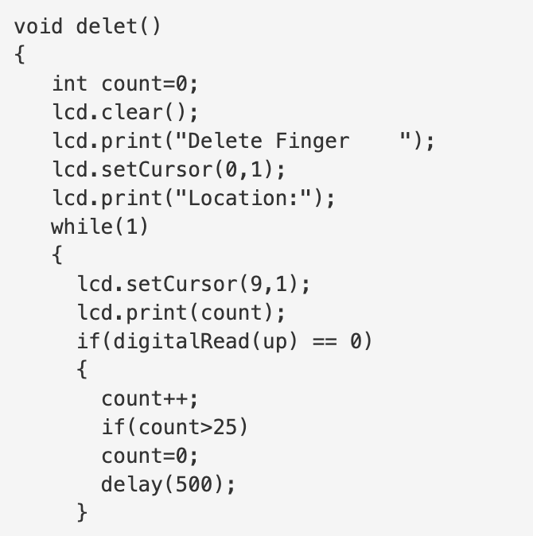

Fig [19]. Deleting a user

**23.**

Method to explain the voting procedure:

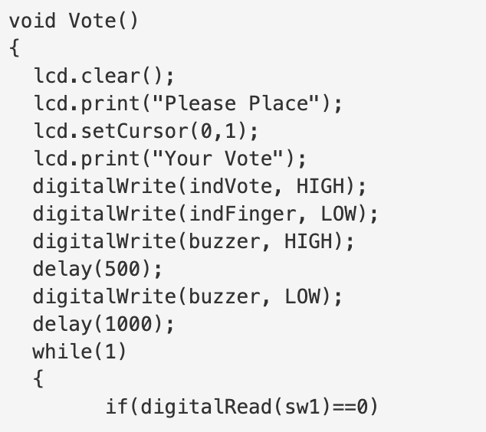

Fig [20]. Arduino Vote Method

**5.3 Constraints, alternatives and tradeoffs**

**Constraint:** I have made the system for 6 users.

**Alternative:** We may be compelled to use a different processor or microcontroller.

**Trade-Off:** It would take 20 seconds per person to give vote but there can never be security breach.

April-May

**24.**

**CHAPTER 6**

**SCHEDULE, TASKS AND MILESTONES**

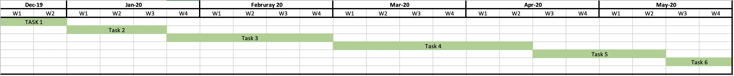

Fig [21]. Task by months and weeks

**Task allotment 1:**

This involved understanding the requirements of the company and what they expect from me in this project. Along with it understanding the requirements of the project and arranging them.

**Task allotment 2:**

Worked on developing the entire web based architecture for the EVM.

**Task allotment 3:**

Started working on the hardware component of EVM.

**Task allotment 4:**

Developed Software part for EVM.

**Task allotment 5:**

Developed ML algorithm for the process of capturing photos and fingerprints. Integrated software and hardware part of the project.

**Task allotment 6:**

Documentation and assembling the project.

**25.**

**CHAPTER 7**

**PROJECT DEMONSTARTION**

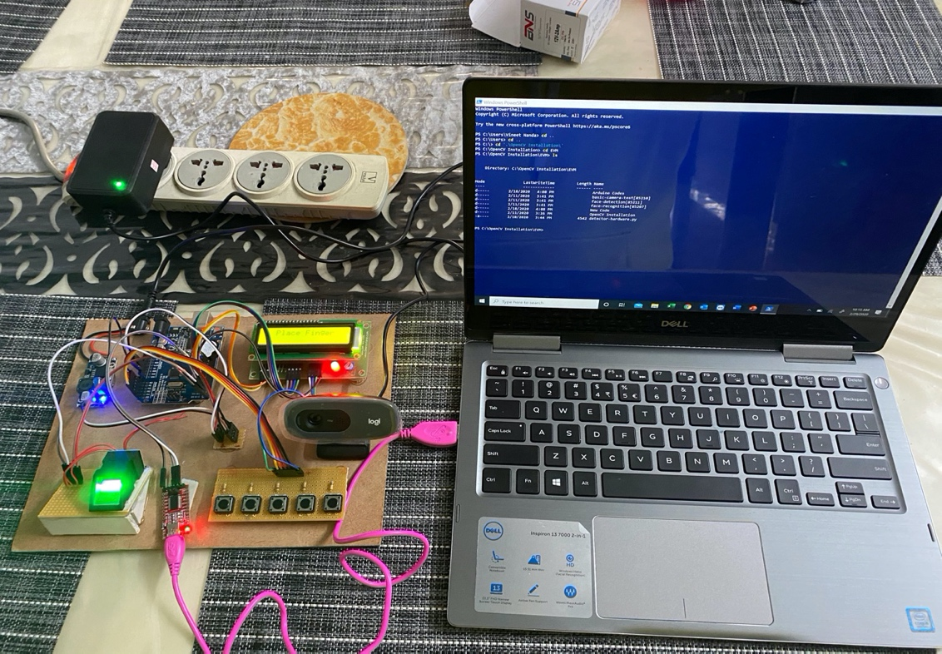

Fig [22]. Complete set up

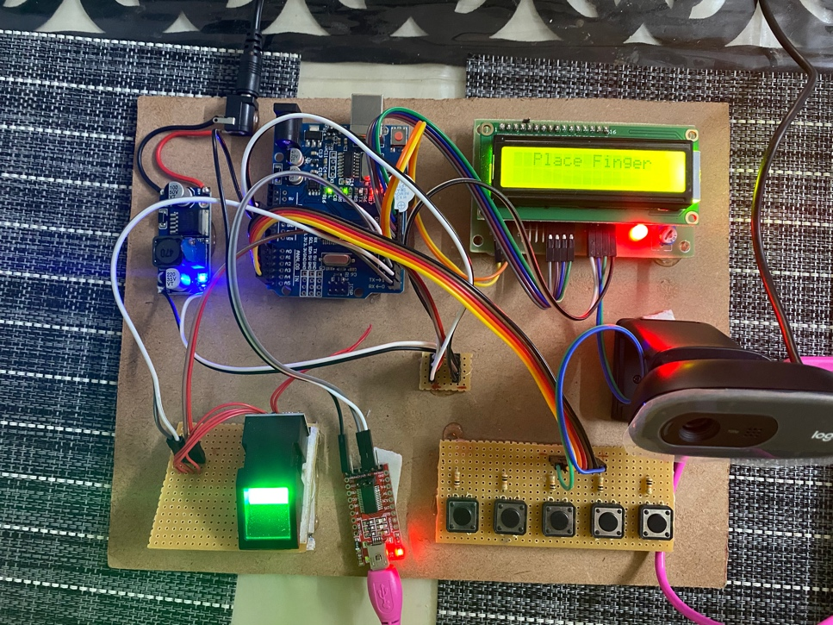

Fig [23]. Only Hardware set up

**26**.

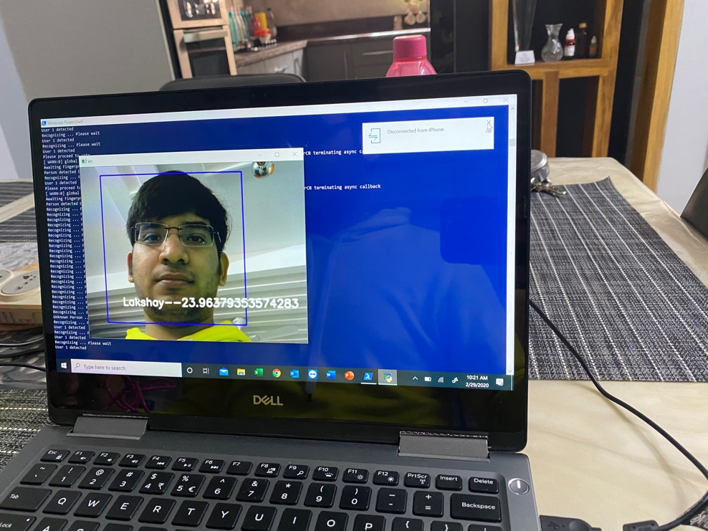

Fig [24]: Facial Recognition working

**Fig 3. Face recognition**

Fig [25]. Method for facial recognition

**27.**

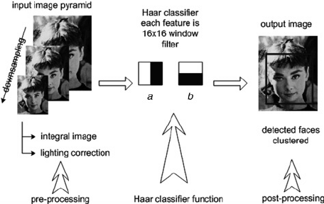

Fig [26]. Classifier being used Is HAAR

Haar Cascade is neural network library that is used to discover object occurrence and calculates how dissimilar a picture or video is. It is an AI relied technology where a strategy is prepared from a massive amounts pictures that it takes as dataset.

The algorithm has four stages:

* Feature Shortlisting
* Covering up for incomplete images
* Adaboost is employed
* Classifiers that are cascading are used thereafter

It reports dissimilar body features in an image but they can spot almost any feature. Primarily, Haar classification need a lot of pictures. After that highlights need to be seperated.

**28**.

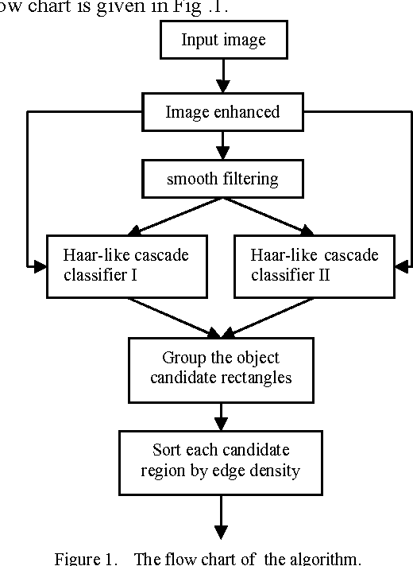

Fig [27]. Algorithm for HAAR

The primary thing is to get the input image. The input image is enhanced by using a lot of filters. Then smoothening is done in order to remove unnecessary noise. There are several types of cascade classifiers that are present, which are employed. Then the objects are grouped together based on similarity with the adjacent pixel. Then each candidate is sorted according to the region by edge density.

**29.**

**CHAPTER 8**

**RESULT AND DISCUSSION**

Feb-March

March-April

April-May

The procedure is very simple and to the point. But, there are many things that can happen because of which somebody won’t be allowed to cast their vote. They are:

* User’s face doesn’t match with the one stored in database
* Registration of the person’s face was not done
* Fingerprint does not match
* Vote was already casted for a person
* Fingerprint was not registered properly

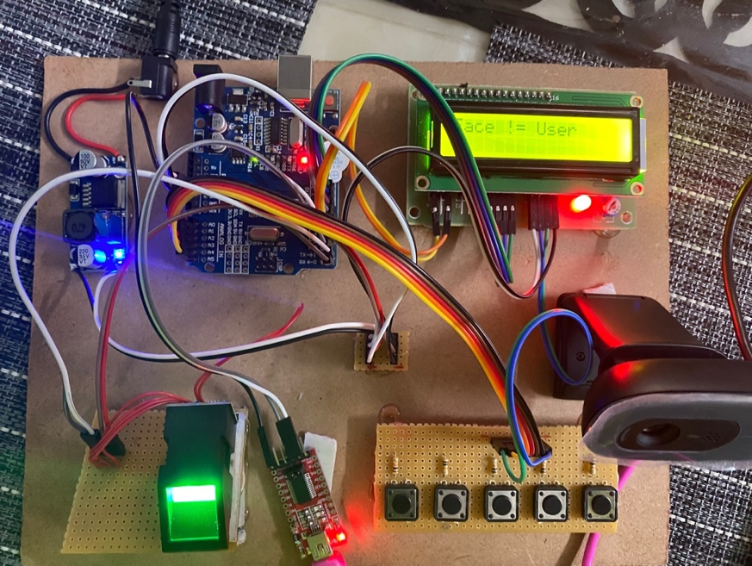

Fig [28]. Face does not match but finger print matches

**30**.

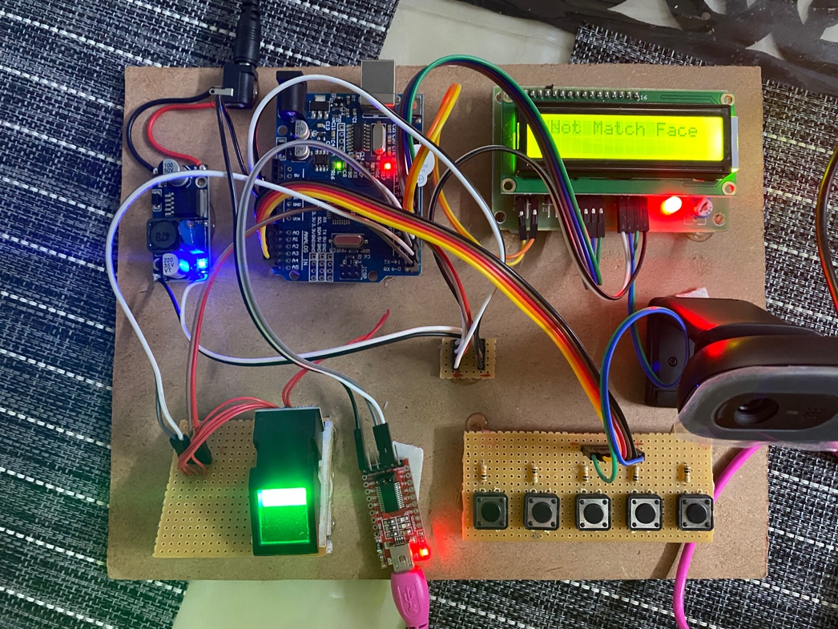

Fig [29]. Face is not detected but finger print matches

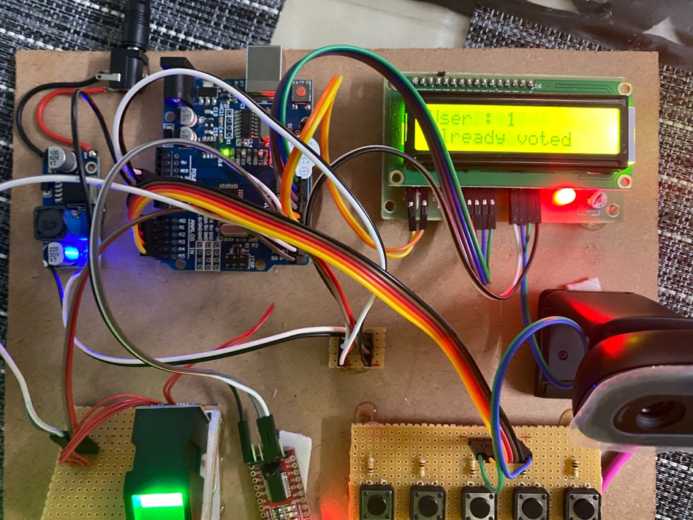

Fig [30]. Person already voted

**31.**

**CHPATER 9**

**REVIEW SUMMARY**

EVM with facial recognition and biometric security is coming out to become another replacement for the already existing system which is capable of providing reliable and mal free elections. I have summarised a framework for the existing Electronic VM with biometric and facial recognition that can be utilised in order to reduce or curb the malpractices that have been taking place in various places. This will help us eliminate bogus voting and redundant vote share, which will lead to more transparent procedure and less cost which will make the entire process cost effective. This project was devised to help introduce a new method that has not been utilised so far by any agency across the globe which help simplify the process by utilising something that every human already has i.e, his own body.

**32.**

**REFERENCES**

1. M. Byrne, K. Greene, and S. Everett, “Usability of Voting Systems: Baseline Data for Paper, Punch Cards, and Lever Machines,” ACM International Conference on Human Factors in Computing Systems, pp. 171–180, 2007.

2. Sussane Caarls, “ E-voting Handbook: Key Steps in the Implementation of E-enabled Elections”, Council of Europe, 2010.

3. Santin, R. Costa and C. Maziero, “ A Three-Ballot- Based Secure Electronic Voting System”, IEEE Transaction on Security & Privacy, Vol. 6(3), pp. 14- 21, 2008.

4. Kumar, “ Electronic voting machine- A review”, IEEE International Conference on Pattern Recognition, Informatics and Medical Engineering (PRIME), pp. 44- 48, 2012.

5. Jain and D. Maltoni, “Handbook of Fingerprint Recognition,” Springer-Verlag, New York, USA, 2003.

6. O. Iloanusi and C. Osuagwu, “Framework for a dynamic Fingerprint Indexing Biometric-based Voting System”, African Journal of Computing & ICTs, pp. 55- 63, Vol. 5(4), 2012.

7. S. Kumar and M. Singh, “Security Enhancement of E- Voting System”, Global Journal of Computer Science and Technology, Volume 12 Issue 5 Version 1.0 March 2012.

8. R. Haenni, E. Dubuis, and U. Ultes-Nitsche, “Research on e-voting technologies." Bern University of Applied Sciences, Technical Report 5, 2008.

9. M. Min and Y. Thein, “Intelligent Fingerprint Recognition System by using geometry approach”, International Conference on the Current Trends in Information Technology (CTIT), pp. 1-5, 2009.

10. M. Khan, “Fingerprint biometric-based self- authentication and deniable authentication schemes for the electronic world." IETE Technical Review, vol. 26(3), pp. 191, 2009.

**33.**

**APPENDIX A**

The EVM accepts a 8 bit slot. The computer has a means to talk with the machine I developed by taking in input or giving out output to the computer which may or may not be 8 or 16 bit. The transfers that occur are 16 bit transfers which are done by performing operations of taking in or giving out inputs. The two functions used are inpu() or outpo() for the transfer. The data that enters is group of macros in the language C which can be easily accessed by the computer in question. The EVM works with this control segment.

**34.**

